
Department | FED
Subject | DSA-2
Academic Year | I-III Semester (2025-26)
Faculty Name | BALAIAH SIR
Student Name | K. Aasritha
Roll Number | 2520030178
Branch | CSE
Course Outcome

Case Study Topic: Medi Flow Hospital – Appointment-Driven Patient Indexing Using BST and AVL Trees
Work Done Summary
In this case study, a BST and an AVL tree were constructed using the given patient IDs. The height and search performance of both trees were analysed. AVL rotations were performed to maintain balance during insertions and deletions. Finally, the lookup efficiency of the BST and AVL tree was compared, showing that the AVL tree provides faster and more reliable patient record searches.s
Implementation Details
- Constructed a Binary Search Tree (BST) by inserting the patient IDs in the given order: 20, 30, 35, 40, 45, 50, 60, 65, 70, 75, 80, 85, and 90.
- Calculated the height of the BST and analysed its lookup performance against the 5ms SLA requirement.
- Built an AVL Tree using the same insertion sequence and performed the required RR rotations to maintain balance.
- Implemented AVL tree operations including insertion, left rotation, right rotation, and height updates.
- Executed the deletion sequence 30, 70, and 50 on the AVL tree and performed rebalancing where necessary.
- Computed the final AVL tree height and compared its lookup time with the plain BST.
Result: Screenshots / Output :
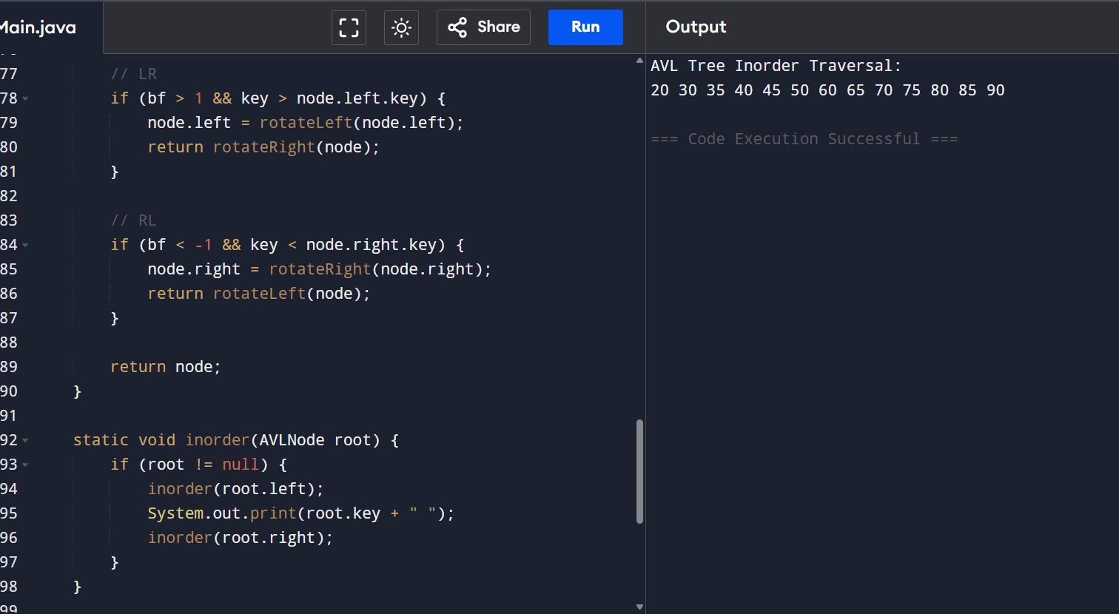

Time Complexity
The AVL Tree maintained balance during insertion and deletion operations using rotations.
Time Complexity:
- AVL Insertion: O(log n)
- AVL Deletion: O(log n)
- AVL Search: O(log n)
Compared to the plain BST (O(n) in the worst case), the AVL Tree provides faster and more efficient patient record lookups.

